BLAST: Basic Local Alignment Search Tool
Hands-On Workbook
Day 1 - Bioinformatics Internship 2026

Learning Objectives
- Understand what BLAST is and why it matters in bioinformatics
- Perform a BLAST search using NCBI BLAST interface
- Interpret BLAST results: E-values, identity %, bit scores
- Identify and analyze orthologs and paralogs
- Document findings in a professional GitHub repository

Exercise 1: Getting Started with NCBI BLAST
Objective: Navigate NCBI BLAST and understand the interface.

Part A: Access NCBI BLAST
Go to https://blast.ncbi.nlm.nih.gov/Blast.cgi and answer the following questions:
Q1: What are the different BLAST programs available? List at least 4.
Answer: ______________blastn,blastp,blastx,tblastn,tblastx_________________________________
________________________________________________________________________

Q2: Name the default database used for nucleotide BLAST searches.
Answer: __________________________________NCBI______________________________________

Part B: E-value Interpretation Challenge
Match each E-value to its interpretation:
E-value | Your Answer | Correct Answer
3e-45 | ____True homolog___ | High similarity
0.45 | ___Low significance____ | Low significance
0.003 | ___High similarity____ | True homolog

Exercise 2: Run Your First BLAST Search
Objective: Search the human insulin gene sequence against NCBI databases.

Step 1: Get the Insulin Gene Sequence
- Go to NCBI Gene (https://www.ncbi.nlm.nih.gov/gene/
- Search for: 'insulin human' or 'INS gene'
- Click on the first result (human insulin)
- Under 'FASTA sequences', click 'CDS FASTA' to get the protein-coding sequence
Q1: What is the length (in base pairs) of the human insulin CDS?
Answer: 333bp
Human insulin CDS -
>lcl|AH002844.2_cds_AAA59172.1_1 [gene=INS] [db_xref=GDB:G00-119-349] [protein=insulin] [protein_id=AAA59172.1] [location=join(2424..2610,3397..3542)] [gbkey=CDS]
ATGGCCCTGTGGATGCGCCTCCTGCCCCTGCTGGCGCTGCTGGCCCTCTGGGGACCTGACCCAGCCGCAG
CCTTTGTGAACCAACACCTGTGCGGCTCACACCTGGTGGAAGCTCTCTACCTAGTGTGCGGGGAACGAGG
CTTCTTCTACACACCCAAGACCCGCCGGGAGGCAGAGGACCTGCAGGTGGGGCAGGTGGAGCTGGGCGGG
GGCCCTGGTGCAGGCAGCCTGCAGCCCTTGGCCCTGGAGGGGTCCCTGCAGAAGCGTGGCATTGTGGAAC
AATGCTGTACCAGCATCTGCTCCCTCTACCAGCTGGAGAACTACTGCAACTAG

Step 2: Set Up BLAST Search
- Copy the CDS sequence (FASTA format with sequence ID)
- Go to NCBI BLAST (https://blast.ncbi.nlm.nih.gov)
- Click 'BLASTN' (nucleotide-nucleotide BLAST)
- Paste your sequence in the 'Enter query sequence' box
- Keep database as 'nr/nt'
Q2: What organism is the second match (after human)?
Answer: Gorilla gorilla gorilla
____________________________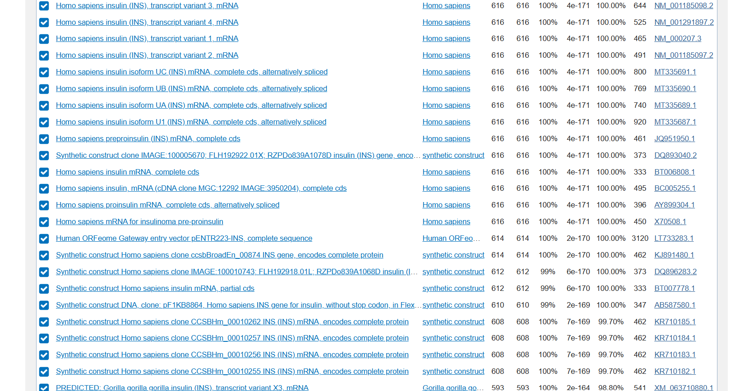

Step 3: Interpret Your Results
Complete the following table for the top 3 BLAST hits:
Hit # | Organism | E-value | Identity % | Ortholog?
1 Homo sapiens insulin (INS), transcript variant 3, mRNA | __Homo sapiens__ | __4e-171__ | __100__ | __none__
2 Homo sapiens insulin (INS), transcript variant 4, mRNA | __ Homo sapiens __ | __4e-171__ | __100__ | _none___
3 Homo sapiens insulin (INS), transcript variant 1, mRNA | __ Homo sapiens __ | __4e-171__ | __100__ | __none__

Exercise 3: Analysis and Interpretation
Q1: Are the top 3 hits orthologs or paralogs of human insulin? Explain why.
Answer: Paralogs as the 3 hits are variants of the same gene in the same organism and have different locus ids(on checking the individual accession ids). This indicates they have been duplicated during evolution.

Q2: What does the high identity % in the top hit tell us about conservation of the insulin sequence?
Answer: It is highly conserved

Q3: Why would an evolutionary biologist be interested in these BLAST results?
Answer: To compare similarity between species based on conservation of the gene and %identity and use that similarity to identify presence of metabolites and other gene products which may have been produced by older species. It can also be used to study phylogenetic relationships and compare ancient and more evolved organisms.
________________________________________________________________________

Exercise 4: GitHub Documentation
Objective: Document your BLAST findings professionally.
Write a brief README section (200-300 words) for your GitHub repository describing:
- What sequence you searched
- What BLAST program and database you used
- Summary of top 3 hits
- Key biological insights from the results
Your GitHub README Draft:
Insulin CDS (coding sequence) of Homo sapiens was downloaded from NCBI.
Nucleotide-nucleotide BLAST was performed (BLASTN) using NCBI’s BLAST, using 'nr/nt' as the database.
Top 3 hits were found to be isoforms or alternative splice variants of the same gene in humans with a 100% query cover and percentage identity.
Following the synthetic constructs, the first ortholog was that in Gorilla gorilla gorilla with a 98.8 % query cover.
Biological meaning behind results – the same INS gene produces multiple mRNA transcripts which are identical in their core coding exons but differ in their untranslated regions. Gorilla being the closest ortholog with a query cover of 100% and percentage identity of 98.8% shows a strong evolutionary relationship between Gorilla and Human.

Reflection Questions
What was the most surprising discovery from your BLAST results?
That insulin had these many variants and they all showed a 100% similarity. Also the fact that Gorilla showed 98.8% similarity to human insulin, in a way indicating their evolutionary relationship.
________________________________________________________________________

